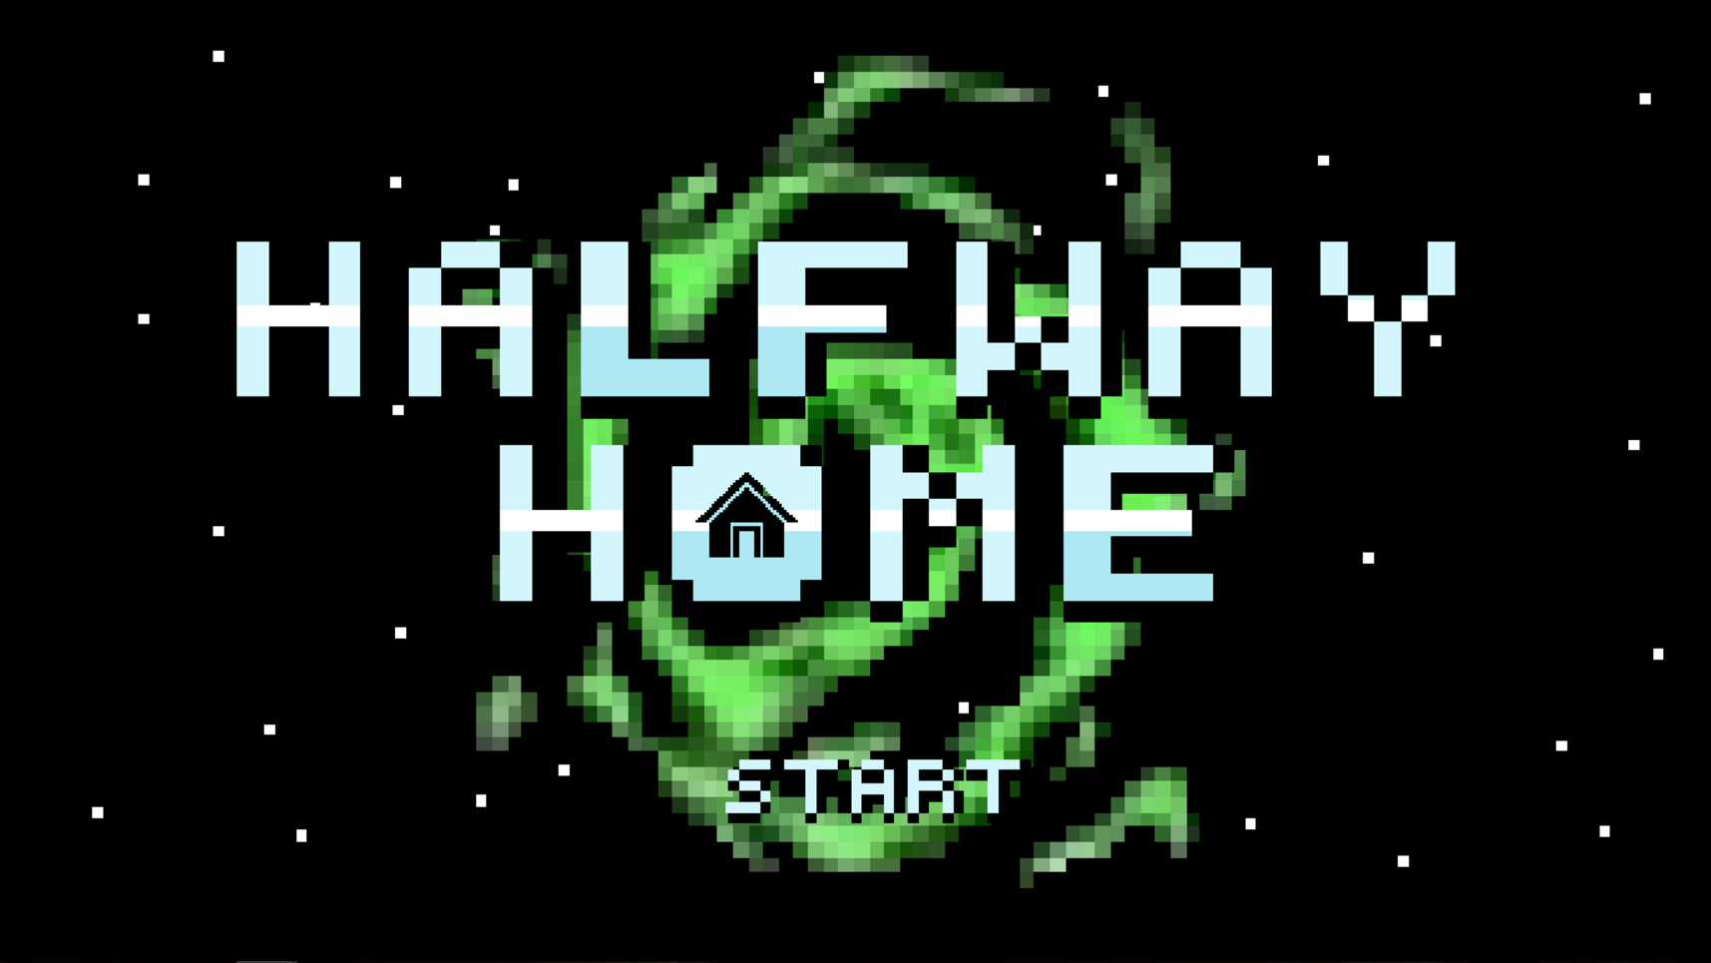

HALFWAY HOME

Video Game Design

Kaysville, Utah

2016 - 2017

**Table of Contents**

Purpose and Description.......................................................................................... 2

How to Play............................................................................................................ 3

Self-Evaluation...................................................................................................... 10

Storyboard............................................................................................................ 11

Dialogue / In-Game Text / Screen Directions…………………………………………………………13

In-Game Pictures………………………………………………………………………………………………..19

Hardware and Software (cost included)................................................................... 23

List of References.................................................................................................. 24

Permission Letters……………………………………………………………………………………………….26

List of Non-Original Materials.................................................................................. 27

Plan of Work Log................................................................................................... 28

Student Copyright Checklist.................................................................................... 31

**Purpose and Description**

Halfway Home is a retro style, top down shooter arcade game created in the fantasy genre. The main character, Johnny, is mysteriously drawn into a portal by a mysterious power only identified as the “Dark Voice” and wakes up in an unknown dimension where he meets four other children: Scotty, Marcus, Eliza, and Timmy. Here he finds that he is trapped between worlds and embarks on a journey to return home, thus the name: “Halfway Home”.

In this new world, Johnny must battle against various mythical monsters such as minotaurs, elemental monsters, dark angels, and demons using his newfound psychic powers. In order to escape, he must journey into "zones" that unlock various doors to progress through the dimension and gain psychic abilities which he uses to defeat the specters that lie within each zone.

While Johnny was largely accepted by the other children that live in “The Hub”, he conflicts with the boy, Scotty, early on. After a falling out with the others, Scotty runs off and Timmy follows to try and reconcile. However, after Johnny returns to the Hub after clearing another zone, he finds out that Timmy has disappeared and the others largely suspect Scotty. Eliza, Timmy’s older sister, asks Johnny for help out of fear that something terrible had befallen him when he ran away to the Dark Zone. However, upon returning from searching the Dark Zone, Johnny returns to the hub to find the Hub devastated and everyone had gone missing except Timmy, who had become evil. Evil Timmy, possessed by the Dark Voice, serves as the final boss, and after defeating him, Johnny must continue the search for his missing friends and a way home.

The narrative of Halfway Home is told through a series of cutscene dialogue and in-game text provided by notes on the ground. The plot of the game holds significance as a social and moral education tool. Similar to the motif of “Loss of Humanity”, Halfway Home displays the conflicting nature of children and degeneration towards distrust. The inclusion of dynamic characters, such as Scotty’s cynicism, Marcus’ stolid kindness, and Timmy’s timid nature leads important plot developments. This provides a form of moral education for our audience as the game handles themes of doubt and portrayal while providing a smooth and fun gaming experience.

Actual gameplay and arcade mechanics are easy to learn with a depth of variety to satisfy level progression. Controls are tailored to a younger audience of “8+” while the larger themes of betrayal and fantasy appeal to teenage video gamers. The style of the game was intentionally built in the 8-bit retro fashion similar to early games of the 1990’s. Halfway Home follows the current genre of indie games, which tailors graphics and mechanics to early gamers that grew up playing on the SNES and Atari-2600 video game consoles.

**How to Play**

Halfway Home is a retro top-down shooter, dungeon crawler game. Upon initialization start a new game from the title menu. Try to advance through the Zones as quickly as possible and collect all available weapons. While enemies will attack you, you do not necessarily need to kill them to advance. Follow notes and directions throughout the levels to complete the necessary tasks to advance. Especially look for switches to open locked doors.

**Controls:**

W Move Forward

A Move Left

S Move Backward

D Move Right

Shift (hold) Sprint (Uses Stamina)

F Interact with objects (Switches and Doors)

Left Mouse Button Shoot (Uses Mana)

Mouse Cursor Aim

Number Keys 1 - 6 Select Weapon

Scroll wheel Scroll through Weapons

Space Melee (Uses Stamina) / Advance Dialogue

**Weapons: (F to Pickup)**

**Bat** **ICON**

Swings in arc around player character

Mana Cost: 20 Stamina

Dmg: 30

Ability: Stuns normal enemies

Deflects projectiles and Chargers

**Helix Shot**Helix Icon.png

Ability: Linear Penetrating Projectile

Mana Cost: 5 Mana

Dmg: 20

**Tri-Shot**

Ability: Linear Triple Shot Penetrating Projectile 

Mana Cost: 10 Mana / Dmg: 30



**Flamethrower**

Ability: Residual Flames Burn Enemies

Mana Cost: 5 Mana per 0.5 sec

Dmg: 10 per 0.05 sec

**Residual Flame**

Damaging Game Object left by Flamethrower

Dmg: 1 per 0.25 sec

**Ice Blast**

Ability: Slows Enemies

Mana Cost: 30 mana

Dmg: 20

**Antimatter Blast**



Ability: Black Hole Consumes Enemies

Mana Cost: 80 mana

Bullet Dmg: 500

Explosion Dmg: 100

**Plasma Cannon**Plasma Cannon.png

Ability: All-Powerful Linear Blast

Mana Cost: 100 mana

Dmg: 750

**PowerUPs:**

**Health**



Health Restoration: 100

**Mana**



Mana Restoration: 25 Mana

**Enemies: (Color Palettes Vary by Zone)**

**Walker**



Standard Enemy

HP: 50

Dmg: 100

**Ranged Enemy**

Shoots Projectiles at Player

HP: 100

Contact Dmg: 100

Projectile Dmg: 50

**Turret**



Stationary, Shoots Projectiles at Player

HP: 300

Projectile Dmg: 50

**Charger**



Pauses then rushes forward at Player

HP: 300

Contact Dmg: 100

**Bosses:**

**Tentacle Monster (Tutorial Zone)**



This large single-eyed Tentacle Monster blocks your path in the forest/swamp Zone. Defeat him with some fancy footwork to avoid the Slime Shots from his vestigial tentacles and eye.

HP: 500

Projectile Dmg: 50

Contact Dmg: 100

**Fire Demon (Fire Zone)**



Balthus the Overlord of the Fire Zone has a special disdain for children, especially psychic ones. Watch out for his flamethrower and residual flames he spews.

HP: 1000

Contact Dmg: 100

Flamethrower Dmg: 10 per 0.25 sec

Residual Flame Dmg: 1 per 0.25 sec

**Possessed Snowman (Ice Zone)**



“Chilly”, Frosty’s underrepresented brother, has risen from the snow to seek vengeance over the Ice Zone. Beware of his Icicle attacks.

HP: 1500

Contact Dmg: 100

Icicle Dmg: 75

**Dark Angel (Dark Zone)**

Khazain, Fallen Angel of the Dark Zone, really just wants the recognition of his parents, but one bad misstep caused his fall from favor. Now he just guards the Dark Zone’s secrets from nosy children.

He likes to spawn familiars and shoots antimatter blasts.

HP: 2000

Contact Dmg: 100

Antimatter Blasts: 150

Familiar Contact Dmg: 100

**Evil Timmy (Dream Zone)**

Timmy has been possessed by the “Dark Voice” and now demands you to test your strength. The only problem is, he has all the same weapons as you.

See Weapons above

HP: 3000

Contact Dmg: 100

**In-Game Objects**

**Note/Paper**



Notes are periodically spaced throughout the Zones that spawn dialog boxes that inform the player to controls, hints, and in-game mechanics. Fewer and fewer notes appear as the game progresses

**Hub Portals**

These steel doors close over the portals to other Zones in the Hub. The outside ring color determines the Zone: Red - Fire Zone, Light Blue - Ice Zone, Dark Purple - Dark Zone.

**Portals**

A mysterious, dark power shrouds these portals that spirited you away. At the same time, they are your main method of transport through the Zones, try to reach these as quickly as possible.

They are also the force that protects you when you respawn.

**Doors: F to Open**



**Weapon Objects: F to pickup**

Helix Icon.png

**Self-Evaluation**

**Jerry Zhou -** *Halfway Home* originally started as a hobby project but developed into a full game where I worked as the main developer and coder. The mechanics of the game were designed in a test deck environment that bashed out trials of the game such as projectiles, enemy AI, and collisions. Hundreds of test trials were often used to perfect mechanics. The individually time-consuming tasks were often delegated among the team to split up the work, such as the realignment of sprites and developing map tiles. A lot of time and effort had to be invested into the game but overall, everyone helped to contribute to the final product.

**Jonathan Tran -** My role on the team was a programmer and map designer. Our team worked collectively through a shared Google drive to share code and graphics for the game. This allowed for multiple members to work on the same or different areas of the game at the same time. For example, the delegation of tasks by our team leader, Jerry, assigned me to work on maps with Winston. Collectively we drew outlines for the map levels then implemented organic, yet pixelated structures on MultiMedia Fusion. Afterwards, the maps and active objects were imported by the head Programmer to be used with the rest of the code for game mechanics, facilitating easy flow of progress for game development.

**James Lee -** I worked as a graphic designer and audio mixer for the team. I mostly worked in Piskel and Audacity to create Pixel art sprite animations for our weapon effects and explosions as well as find and edit audio files for use within the game. I meticulously searched for royalty free music that matched the mood of the game, because the sound effects can really make or break good retro games.

**Winston Stucki** - I primarily worked on the documentation for *Halfway Home*, as well as the storyboard. I was also in charge of the concept and story of the game. I aimed to make our game be unconventional as well as entertaining. I wanted to make the documentation be presentable and accurately depict our game for when we had to present it at TSA. I also created some of the graphics, including the normal enemy sprite as well as some of the texture tiles.

**Alexei Garcia -** I was brought onto the Video Game Team for my artistic abilities and served as the graphics head for the team. Our decision was to create a retro style game that utilized pixel art for the graphics. All in-game objects, enemies, characters, animations, and bosses are original sprites that were created by me and other members. I personally designed the bosses and main character portraits as the most detailed graphics of the game to create a special highlight of pixel art and how it can be used for realistic effects. I also contributed to documentation after completing graphics.

**In-Game Pictures**

**Tutorial Zone Boss Fight**

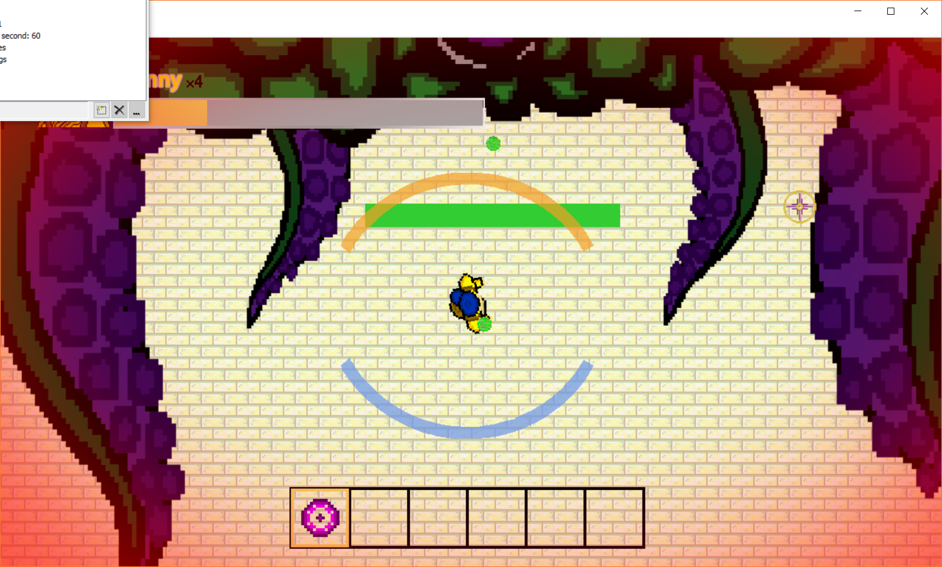

**Fire Zone Boss Fight**

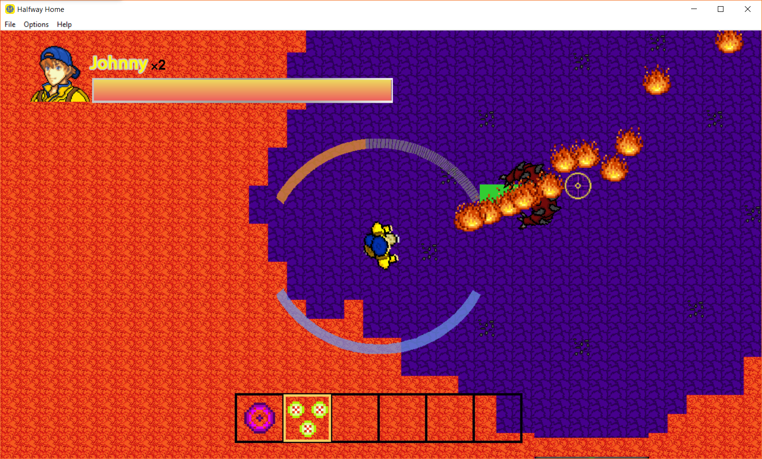

**Ice Zone Boss Fight**

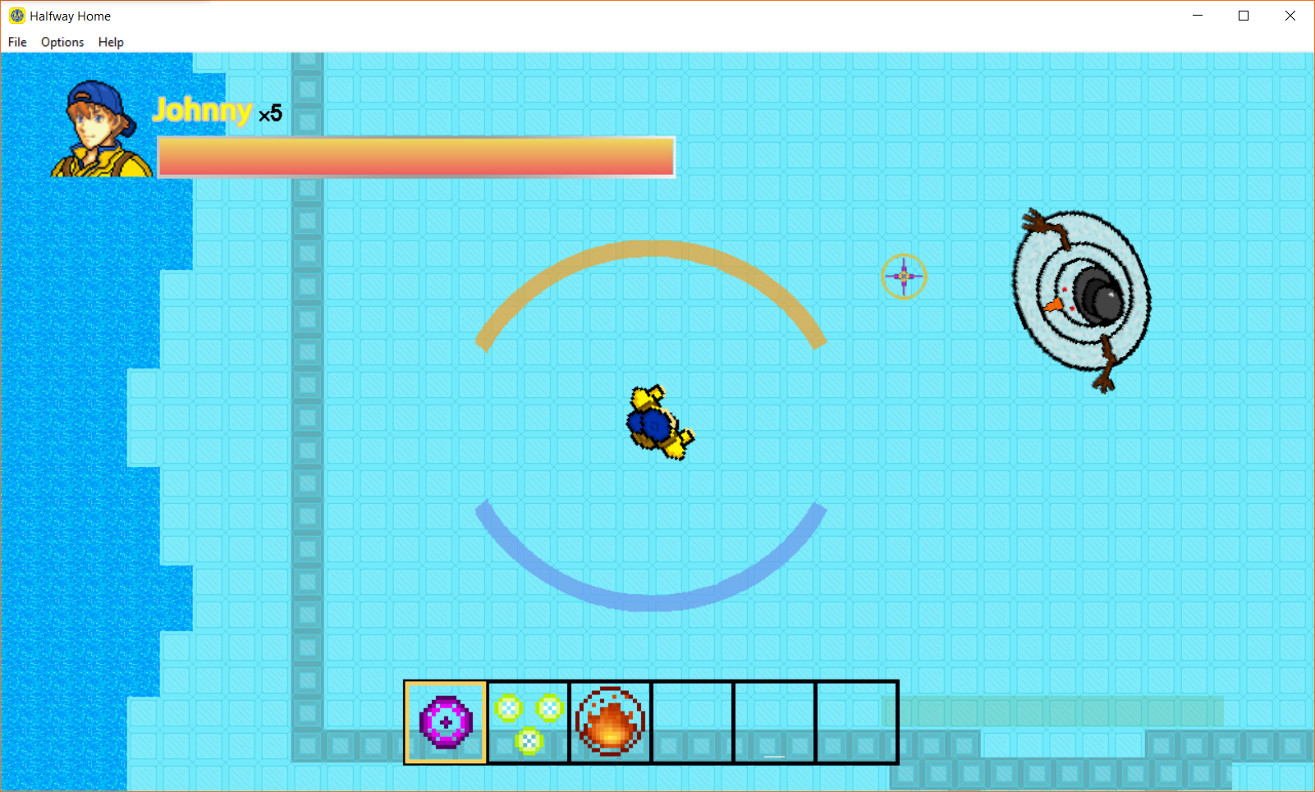

**Death Cutscene (Dark Voice)**

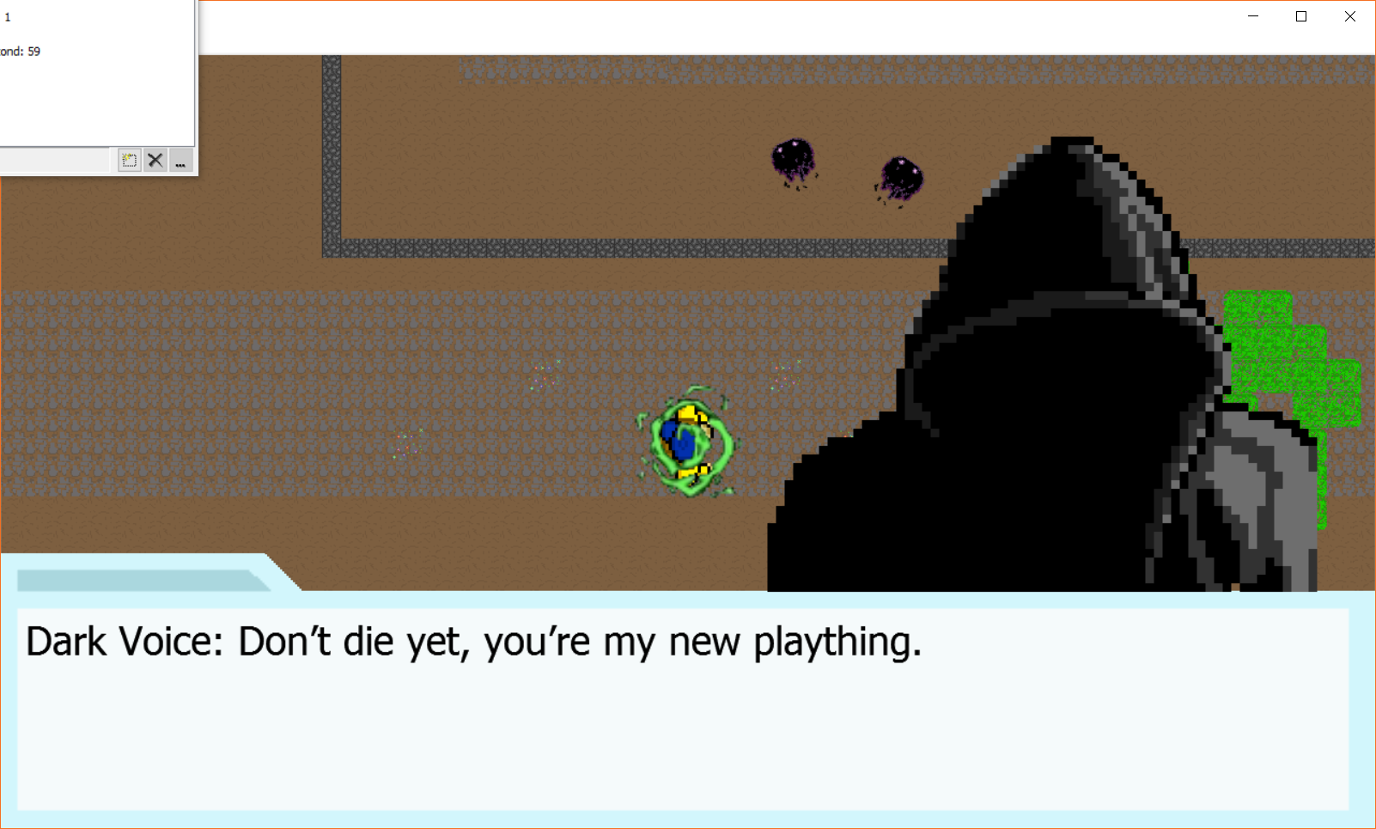

**Johnny Cutscene**

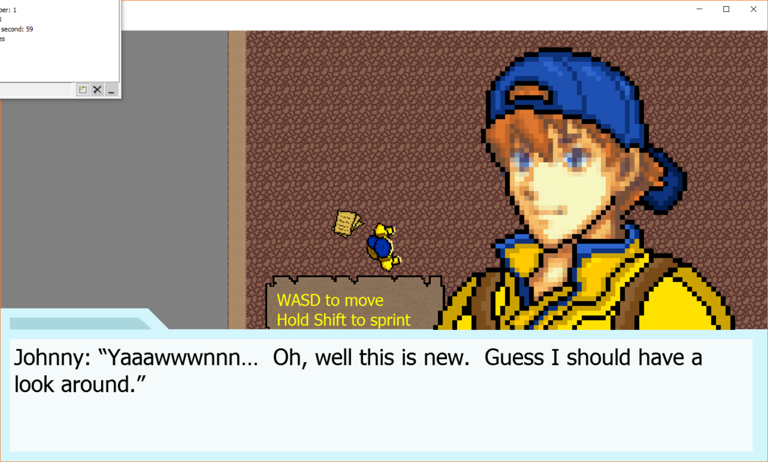

**Software Used**

|  |  |  |
| --- | --- | --- |
| **Program** | **Actual Cost** | **Retail Cost** |
| Windows 10/8 | Free/Free | $109.95/$40.00 |
| Microsoft Word 2015/2016 | Free | Free |
| Google Drive | Free | Free |
| Google Docs | Free | Free |
| Google Sheets | Free | Free |
| Photoshop Elements 11 | Free | $107.00 |
| Audacity 2.1.2 | Free | Free |
| Multimedia Fusion 2.5 | Free | $1.00 |
| Piskelapp | Free | Free |

**Hardware Used**

|  |  |  |
| --- | --- | --- |
| **Hardware** | **Actual Cost** | **Retail Cost** |
| 2015 HP Envy 15t | Free / Preowned Personal Computer | $989.00 |
| 2016 Toshiba Satellite | Free / Preowned Personal Computer | $649.99 |
| 2015 ASUS UX305 F | Free / Preowned Personal Computer | $749.99 |
| Logitech M185 Mouse | Free / Preowned | $4.99 |

**List of References**

Graphics Software:

Descottes, Grosbouddha Julian. "Pixel Art and Animated Sprites." Piskel - Free Online Sprite Editor. N.p., n.d. Web. 15 Mar. 2017. <http://www.piskelapp.com/>

Audio:

**"Winter Reflections" Kevin MacLeod (incompetech.com)**

**Licensed under Creative Commons: By Attribution 3.0 License**

[**http://creativecommons.org/licenses/by/3.0/**](http://creativecommons.org/licenses/by/3.0/)

**"Airship Serenity" Kevin MacLeod (incompetech.com)**

**Licensed under Creative Commons: By Attribution 3.0 License**

[**http://creativecommons.org/licenses/by/3.0/**](http://creativecommons.org/licenses/by/3.0/)

**"Ghost Story" Kevin MacLeod (incompetech.com)**

**Licensed under Creative Commons: By Attribution 3.0 License**

[**http://creativecommons.org/licenses/by/3.0/**](http://creativecommons.org/licenses/by/3.0/)

**"Mystery Bazaar" Kevin MacLeod (incompetech.com)**

**Licensed under Creative Commons: By Attribution 3.0 License**

[**http://creativecommons.org/licenses/by/3.0/**](http://creativecommons.org/licenses/by/3.0/)

**"Bumba Crossing" Kevin MacLeod (incompetech.com)**

**Licensed under Creative Commons: By Attribution 3.0 License**

[**http://creativecommons.org/licenses/by/3.0/**](http://creativecommons.org/licenses/by/3.0/)

**“Metalmania” Kevin MacLeod (**[**incompetech.com**](http://incompetech.com/)**)**

**Licensed under Creative Commons: By Attribution 3.0 License**

[**http://creativecommons.org/licenses/by/3.0/**](http://creativecommons.org/licenses/by/3.0/)

**“Large Fireball Sound” Mike Koenig (soundbible.com)**

**Licensed under Creative Commons: By Attribution 3.0 License**

[**http://creativecommons.org/licenses/by/3.0/**](http://creativecommons.org/licenses/by/3.0/)

**shortened and looped**

**“Flash Animation Sound” BlastWaveFx.com (soundbible.com)**

**Licensed under Creative Commons: By Attribution 3.0 License**

[**http://creativecommons.org/licenses/by/3.0/**](http://creativecommons.org/licenses/by/3.0/)

**shortened and looped**

**“Laser Cannon Sound” Mike Koenig (soundbible.com)**

**Licensed under Creative Commons: By Attribution 3.0 License**

[**http://creativecommons.org/licenses/by/3.0/**](http://creativecommons.org/licenses/by/3.0/)

**shortened**

**“Shooting Star Sound” Mike Koenig (soundbible.com)**

**Licensed under Creative Commons: By Attribution 3.0 License**

[**http://creativecommons.org/licenses/by/3.0/**](http://creativecommons.org/licenses/by/3.0/)

**“Alien Machine Gun Sound” Matt shortenedillo (soundbible.com)**

**Licensed under Creative Commons: By Attribution 3.0 License**

[**http://creativecommons.org/licenses/by/3.0/**](http://creativecommons.org/licenses/by/3.0/)

**Shortened**

**“Flyby Sound” Conor (soundbible.com)**

**Licensed under Creative Commons: By Attribution 3.0 License**

[**http://creativecommons.org/licenses/by/3.0/**](http://creativecommons.org/licenses/by/3.0/)

**“Laser Machine Gun Sound” Mike Koenig (soundbible.com)**

**Licensed under Creative Commons: By Attribution 3.0 License**

[**http://creativecommons.org/licenses/by/3.0/**](http://creativecommons.org/licenses/by/3.0/)

**shortened**

**“Dark Laugh Sound” HopeInAwe (soundbible.com)**

**Licensed under Creative Commons: By Attribution 3.0 License**

[**http://creativecommons.org/licenses/by/3.0/**](http://creativecommons.org/licenses/by/3.0/)

**shortened**

**“Poltergeist Sound” Mike Koenig (soundbible.com)**

**Licensed under Creative Commons: By Attribution 3.0 License**

[**http://creativecommons.org/licenses/by/3.0/**](http://creativecommons.org/licenses/by/3.0/)

**Shortened**

**“Sleigh Bells Ringing Sound” Mike Koenig (soundbible.com)**

**Licensed under Creative Commons: By Attribution 3.0 License**

[**http://creativecommons.org/licenses/by/3.0/**](http://creativecommons.org/licenses/by/3.0/)

**Shortened**

**“Creepy Laugh Sound” Adam Webb (soundbible.com)**

**Public Domain**

**Shortened**

**“Switch Sound” Mike Koenig (Soundbible.com)**

**Licensed under Creative Commons: By Attribution 3.0 License**

[**http://creativecommons.org/licenses/by/3.0/**](http://creativecommons.org/licenses/by/3.0/)

**“Ta Da Sound” Mike Koenig (soundbible.com)**

**Licensed under Creative Commons: By Attribution 3.0 License**

[**http://creativecommons.org/licenses/by/3.0/**](http://creativecommons.org/licenses/by/3.0/)

**Shortened**

**“Big Door Closed Sound” Clemens F (soundbible.com)**

**Public domain**

**Shortened**

**“Lion Growling Sound” Mike Koenig (soundbible.com)**

**Licensed under Creative Commons: By Attribution 3.0 License**

[**http://creativecommons.org/licenses/by/3.0/**](http://creativecommons.org/licenses/by/3.0/)

**shortened**

**Permission Letters**

NO copyrighted materials were used in the production of *Halfway Home*. Audio material from Creative Commons and cited references above. Everything else not mentioned, including game code, sprites, pixel art, map tiles, and game objects are original and made by the members on this TSA team.

**List of Non-Original Materials**

Audio

(Ice World Ambient Music) **"Winter Reflections" Kevin MacLeod**

(Hub Ambient Music) **"Airship Serenity" Kevin MacLeod (incompetech.com)**

(Dark Zone Ambient Music) **"Ghost Story" Kevin MacLeod (incompetech.com)**

(Tutorial Zone Ambient Music) **"Mystery Bazaar" Kevin MacLeod (incompetech.com)**

(Fire Zone Ambient Music) **"Bumba Crossing" Kevin MacLeod (incompetech.com)**

(Dream Zone Ambient Music) **“Metalmania” Kevin MacLeod (**[**incompetech.com**](http://incompetech.com/)**)**

(Flamethrower Sound Effect) **“Large Fireball Sound” Mike Koenig (soundbible.com)**

(Triple-Shot Sound Effect) **“Flash Animation Sound” BlastWaveFx.com (soundbible.com)**

(Antimatter Blast Sound Effect) **“Laser Cannon Sound” Mike Koenig (soundbible.com)**

(Ice Blast Sound Effect) **“Shooting Star Sound” Mike Koenig (soundbible.com)**

(Ranged Enemy Sound Effect) **“Alien Machine Gun Sound” Matt shortenedillo (soundbible.com)**

(Charger Enemy Sound Effect) **“Flyby Sound” Conor (soundbible.com)**

(Turret Enemy Sound Effect) **“Laser Machine Gun Sound” Mike Koenig (soundbible.com)**

(Dark Angel Sound Effect) **“Dark Laugh Sound” HopeInAwe (soundbible.com)**

(Evil Timmy Sound Effect) **“Poltergeist Sound” Mike Koenig (soundbible.com)**

(Possessed Snowman Sound) **“Sleigh Bells Ringing Sound” Mike Koenig (soundbible.com)**

(Demon Sound Effect) **“Creepy Laugh Sound” Adam Webb (soundbible.com)**

(Lever Sound Effect) **“Switch Sound” Mike Koenig (Soundbible.com)**

(Pickup Sound Effect) **“Ta Da Sound” Mike Koenig (soundbible.com)**

(Door Open Sound Effect) **“Big Door Closed Sound” Clemens F (soundbible.com)**

(Tentacle Boss Sound Effect) **“Lion Growling Sound” Mike Koenig (soundbible.com)**